ASKING ADVICE OF DR UMAR ELAHI AZAM
Vol. 3
Emails from the Archive of Dr Umar Azam
Manchester, UK
February 2015

dream interpretation required
People
- TEHSEEN [NAME HAS BEEN CHANGED]

- 20 Jul 2014
To
- me
Dear Sir

I have seen two strange dreams in this Ramzan one between tahajud and Fajr prayer (just before I woke up and heard azan e fajr, second at the time of Chasht prayer around 9:00 to 9:30 per my time zone (PST i.e). My house reportedly has some Asarat like jinn existence however any knowledgeable people have confirmed that the Asarat are not on any of the residents yet. These beings just live in a secluded area of the house.

1- 1st Dream- before Azan e Fajr

I see a king who is left with a deserted empty field only as his empire, no troops to support him except his youngest kid (5-6 year old)... the prince and teh king are standing in their empire facing a castle which is separated from the king's vast field with a small road (about 2-3 feet wide) Outside the castle they see the head of a foreign army smiling at them. despite the king's distrust the prince moves forward towards the foreign knight (who appears to be a christian) to inquire about his intents... The foreign knight behaves cordially and responds that his troops intend not to harm the prince or the knight. However, going forward the prince sees a small kid getting out of the foreigner's castle and running away in the small street, whom he follows out of curiosity. A few feet from the starting point he sees two identical twin females (about 15-16 year old) who try to stop him or befriend him in order to persuade to stop him but the prince again does not listen to them ... the girls cry out loud at this neglect. By this time I realize that the kid is myself and I am seeing not a merely a viewer of this whole occurrence. Due to divided attention the prince (that is now I know ...myself) looses sight of the kid ahead.but he keeps following the path somehow he knows which track to take and he finally catches the kid hiding in a wall . Initially surprised and disappointed at his capture the alien kid (who appears just as a human child) takes me within that cave like opening within that wall and takes me upstairs where he makes very very white cotton like material using some machinery to earn his bread and butter. He also teaches me how to make that stuff. suddenly eh electricity shuts down and I start to operate the machine manually using a wooden rod... but I don't stop making that cotton wool like material...... in the dark I see towards my right side and I find myself under the huge plantation in the courtyard of my own house I am naked and standing in a bath tub and washing myself under open sky without any fear of being seen by any of the neighbors.... its midnight and I am all wet but my need to take a bath does not suffice my mother is lying on my back to teh left side on a bed stead... she forbids me and goes inside very irritably I follow her and tell her that i think i have mistakenly poured water on my Taweez and hand her the taweez to see if its actually wet or is it ok.

2nd Dream.

I am standing near the front gate of my house and suddenly a black dog (with yellowish brown belly ( i don't know which breed is it?) goes out of the house e appears to be a pet dog.I feel saddened but I close the door tightly behind the dog. In a few seconds the dog come back with two other dogs and tries to enter the house i feel displeased at this ....and don't open the door . My head is tightly covered with my dupatta (scarf) but I try to hide my face with my hand or try to keep my face away from the dogs yet I hold the door tightly because I fear the dogs (which are now around three to four) will break it. Then a fifth dog comes in ... very powerful and speaks in human language who almost pulls the door away from the ground but the door is too strong. He then tries to guide the rest how to open the door or break it .I keep seeing the paws of my dog and another's hanging in from the side bars of the iron gate and I keep feeling sympathetic and helpless because I cant bring them in as I am afraid of the other dogs whom they are accompanying. The fifth dog brings back a strong wooden stick to open the iron door but it does not work. Even though I know they wont be able to break the gate Untill I woke up I keep feeling scared and try to keep my face hidden while staring at the paws of my own dog and one other dog while I am afraid of the herd also.

Please help me understand these dreams... if it is a sign that teh asarat of jinns have again come back in ur house then help me avoid it from affecting me or my family. I am especially confused as to the making of wool... and the kid teaching me the process. Who are teh two identical girls.. are they some relatives of mine or are they some aliens as well?

Thanks for your time

I hope I get some answers here

Regards

TEHSEEN

RE: YOUR DREAMS
UMAR AZAM <dr.u.azam@gmail.com> | 7/20/14
to TEHSEEN

WA LAIKUM SALAM, TEHSEEN

THIS IS TO CONFIRM THAT I RECEIVED YOUR EMAIL AT ONE OF MY YAHOO! EMAIL ADDRESSES.

SINCE YOUR TWO DREAMS CONSIST OF SUBSTANTIAL CONTENT, I NEED TIME [A DAY OR TWO TO ANALYSE THEM PROPERLY.

IN THE MEANTIME, BECAUSE IT IS THE HOLY MON TH OF RAMADAN, I'M GOING TO SEND YOU A ONE-OFF BATCH OF VALUABLE RESOURCES BY EMAIL IN A FEW MINUTES. I TRUST YOU WILL FIND THEM V. USEFUL.

PLEASE NOW WAIT FOR YOUR INTERPRETATIONS.

ALLAH'S BLESSINGS,

DR UMAR
UMAR AZAM <dr.u.azam@gmail.com> | 7/21/14
to TEHSEEN

SALAM, TEHSEEN

THE INTERPRETATION OF SPINNING COTTON IN A DREAM DEPENDS ON WHETHER YOU WERE SPINNING FAST OR SLOWLY:

Spinning — (Yarn) If a woman sees herself working on a spinning wheel and quickly trying to finish her work in a dream, it means that a traveller will soon come home, or that an expected visitor will arrive. If she sees herself taking her time in spinning her wool in a dream, it means that either she or her husband will undertake a journey. If the thread breaks inside the bobbin in her dream, it means cancellation of her plans to travel. If she sees herself in a dream spinning cotton threads, it means separation from her husband. During such a separation, she will cease asking her husband for her bridal dower, and later on she will return to him. If she sees herself spinning linen in a dream, it means that she will seek the company of righteous people to acquire wisdom and knowledge. If a man sees himself spinning cotton, or linen in a dream, it means that he will suffer humiliation, or he may engage in a job which he cannot do properly. If the threads he is spinning turn thin in the dream, it means that he toils hard through his work but fails to do it properly. If the threads turn too thick in the dream, it means that he will undertake a business trip and reap success from it. If a man sees a woman spinning cotton in her house in a dream, it means that she will betray her husband with someone else. If one sees himself spinning wool, fur, or hair in his dream, it means that he will undertake a profitable business trip. To undo a spun thread in a dream means renouncing one's allegiance, or breaking one's promise, or denying one's commitment. (Also see Ball of thread; Pledge of allegiance; Spindle) Source:Strong

www.myislamicdream.com

IS A VERY VERY USEFUL SITE TO KNOW WHAT YOUR DREAMS MEAN!!!

THE GOOD NEWS IS THAT SPINNING COTTON IN A DREAM CAN ALSO MEAN MONEY COMING IN FOR YOUR FAMILY.

YOUR BEING NAKED IN BATH MEANS A FRESH START AFTER UNCERTAINTY IN LIFE.

THE 2 GIRLS COULD BE THE NEXT TWO YEARS IN YOUR LIFE, WHICH WILL INSHALLAH BE GOOD.

THE DOGS REPRESENT ENEMIES THAT YOU HAVE.

I HAVE MADE A NEW SITE: http://dr-umar-azam-chronological.weebly.com AND MASHALLAH YOU CAN TAKE WHICHEVER QURANI TAWEEZ YOU WANT FROM IT 24/7. PRINT OUT THE TAWEEZ AND THEN KEEP IT IN A LOCKET AROUND YOUR NECK.

KEEP IN TOUCH AND TELL ME WHAT YOU THINK OF THAT WEBSITE, TALAT.

DR UMAR

TEHSEEN | 8/22/14
to me

Hi Dr Umar Sb

One of the dreams has literally come true. The one about dogs trying to break in the house and me trying to save face. My mothers intervention saved me as in my dream I saw me close the main gate tightly......
Now I saw another new dream one following that last dream. I saw myself sleeping in my room and my enemies (my elder married sister whom my mom has disowned due to her disobedience etc) have broke in the house and they are searching me in every room downstairs while I am sleeping upstairs. I know what it means, I am being warned again and again and i am not taking a lesson. I want you to guide me if there is something , some sadaqah that i can take to avoid this misfortune at the hands of my own blood relatives. I have no money at all... I am broke and I am trapped in such a situaton that I a unable to help myself. What am I supposed to do? I cant leave my house at once I am trying to move abroad but things are slowing down
I dont know why... I need you to help me see if I am doing womething wrong to fix my issues and get out of thsi house. My life is literally in danger.
UMAR AZAM <dr.u.azam@gmail.com> | 8/22/14
to TEHSEEN

Use
TAWEEZ
on
http://dr-umar-azam-chronological.weebly.com
TEHSEEN | 8/22/14
to me

Sir I am unable to find which website of the thirty contains information on Taweezat. I already have few tawwezat on me but I really dont know why this could not be prevented? Please can you somehow tell me if moving out is a feasible option or would it create more enemies for me ?
Coz my mother is my sole guardian at this point in time I fre that if I leave my other relatives will poison her brain to make me even more alone and helpless.
UMAR AZAM <dr.u.azam@gmail.com> | 8/22/14
to TEHSEEN

TRY TO DO A SUITABLE WAZIFA TO GET THE ANSWERS YOU NEED FROM ALLAH, TALAT

USE:

www.wazifas.com

DR UMAR

THE FILIPINO TRANSLATION OF THE HOLY QURAN IS ATTACHED!
FILIPINO QURAN | x
UMAR AZAM <dr.u.azam@gmail.com> | 11/22/13
to faisali_2000

filipino-quran.pdf

SALAM, BR FAISAL

THIS PDF IN THE MINDANAO LANGUAGE IS FROM THE SUPERB WEBSITE:

www.qurandownload.com

PLEASE FEEL FREE TO GO ONTO THE SITE AND DOWNLOAD OTHER V. INTERESTING LANGUAGE TRANSLATIONS OF THE QURAN TOO.

ALLAH'S BLESSINGS ON YOU.

DR UMAR

Pious Muslim
UMAR AZAM <dr.u.azam@gmail.com> | 8/13/14
to Syed.Mohiuddin

Salam, Br Syed Mohiuddin
From ur responses, I can tell that u are a genuine and pious Muslim, so I have sent u more Resources: Quran dictionary, Quran Word by Word et. al. Allah bless u with everything good in both the worlds! Keep up ur valuable communications. Dr Umar

Syed.Mohiuddin@emerson.com | 8/13/14
to me

Salam Dr. Azam

I wish I could become what you think of me, but I am far from it.

Thanks for all your information and attachments. I have gone through 3 of them, but still a lot more to go.
Actually, I am little behind catching up my e-mails due to my travelling schedule. Rest assured that all your e-mails and attachments will be read and move forward with all the appreciation from depth of my heart.

I value your work. As you know there is not that much material on Quran and Sunnah available in English from right sources. This is the reason your work is very valuable. You may not see the fruits of your work in this Duniya, but definitely you will see it in Jannah, Insha’Allah.

A lot of work to be done in converting the material in English to maintain our aqheedah. You are doing a great work. Please keep it up and Aakhira is yours to enjoy.

Love you as a brother for sake of Allah SWT
Minhaj
From: UMAR AZAM [mailto:dr.u.azam@gmail.com]
Sent: Tuesday, August 12, 2014 11:04 PM
To: Mohiuddin, Syed M [CLIMATE/AC/SID]
Subject: Pious Muslim
UMAR AZAM <dr.u.azam@gmail.com> | 8/13/14
to Syed.Mohiuddin

JAZAKALLAH, BR MOHIUDDIN, I WILL TRY TO DO EVEN MORE, PLEASE SEE:

http://powerofdurood.weebly.com

&

http://dr-umar-azam-chronological.weebly.com

AND THEN SIGN MY GUESTBOOKS WITH YOUR GENUINE COMMENTS ABOUT EACH PARTICULAR SITE.

DR UMAR

Faiza Raymode <faizahmu@yahoo.com> | 8/12/14
to me

- Assalamualaikum Dr Umar

- Hope you are enjoying a good health by the grace of Allah.

- I would like to know what Quraan and Islam says about adopting a child.

- Jazak Allah
- =====================================================================================================

UMAR AZAM <dr.u.azam@gmail.com> | 8/12/14
to Faiza

- WA LAIKUM SALAM, FAIZA

- MY EXPERTISE IN THIS AREA IS NOT PROLIFIC!

- PLEASE USE THE FOLLOWING LINKS REGARDING ADOPTING A CHILD IN ISLAM:

- http://islam.about.com/cs/parenting/a/adoption.htm

- http://www.al-islam.org/articles/adoption-islam-sayyid-muhammad-rizvi

- http://www.islamweb.net/emainpage/articles/135420/adoption-in-islam

- AND YOU CAN FIND LOADS MORE INFO BY ENTERING: ADOPTION IN ISLAM IN GOOGLESEARCH ENGINE.

- DR UMAR

NOT CLEAR
UMAR AZAM <dr.u.azam@gmail.com> | 8/12/14
to wanidada8

SALAM, BR MOHD SHAFI WANI

THANK YOU FOR YOUR GUESTBOOK ENTRY ON MY FREE HOLY QURAN WEBSITE.

PLEASE TYPE CLEARLY IN FULL CAPITALS YOUR NAME AND COMPLETE ADDRESS INCLUDING COUNTRY WITHOUT ANY ABBREVIATIONS TO RECEIVE THE HOLY QURAN AND ISLAMIC BOOKS.

I WILL THEN REFER YOUR DETAILS TO EGYPT AND TURKEY.

AND PLEASE TELL ME HONESTLY WHAT YOU THOUGHT OF MY WEBSITE.

DR UMAR

Recipe for a Successful Marriage
The Qur'an Foundation <thequranfoundation@gmail.com> | 8/5/14
to bcc: thequranfounda.

Recipe for a Successful Marriage
“Our Lord! Grant that our spouses and our offspring be a comfort to our eyes, and give us the grace to lead those who are conscious of You” (Furqaan 74).
Question: Every human being by nature has an instinct to dispute. This instinct becomes more manifest between the husband and wife, thus leading to marital disputes. How can this instinct be controlled?
Answer: Consider the following ten points to control the instinct of dispute and maintain a happy marriage.
1. Fear Allah: It was the noble practice of Nabi salallahu alayhi wasallam to conscientise the spouses about the fear for Allah before performing a Nikah by reciting the verses (Nisa v14, Ahzab v69, Aali-Imraan v101) from the Quraan. All the verses are common in the message of Taqwa (fear of Allah). The spouses will be first committed to Allah before being committed to their partner. There can be no doubt in the success of a marriage governed by the fear of Allah.
2. Never be angry at the same time: Anger is the root cause for all marital disputes. One Sahabi came to Rasulullah salallahu alayhi wasallam and sought some advice. Rasulullah salallahu alayhi wasallam replied, control your anger. The same advice was rendered three times. (Mishkaat pg.433; HM Saeed)
3. If one has to win an argument, let it be the other: Nabi salallahu alayhi wasallam said: “Whoever discards an argument despite being correct shall earn a palace in the centre of Jannah. (Ibid pg.412)
4. Never shout at each other unless the house is on fire: Luqman (Alaihis Salaam) while offering advice to his son said: ” and lower your voice for verily the most disliked voice is that of a donkey”. (Surah Luqman v19)
5. If you have to criticize, do it lovingly: Rasulullah salallahu alayhi wasallam said, ‘A Mu’ min is a mirror for a Mu’min.’ (Abu Dawud vol.2 pg.325; Imdadiyah) Advise with dignity and silently.
6. Never bring up mistakes of the past: Nabi Muhammad salallahu alayhi wasallam said: “Whoever conceals the faults of others, Allah shall conceal his faults on the day of Qiyaamah.” (Mishkaat pg.429; HM Saeed)
7. Neglect the whole world rather than your marriage partner: Nabi Muhammad salallahu alayhi wasallam confirmed the advice of Salman to Abu-Darda (Radiayallaahu Anhu) for neglecting his wife. “Verily there is a right of your wife over you.” (Nasai Hadith2391)
8. Never sleep with an argument unsettled: Abu Bakr radiallahu anhu resolved his dispute with his wife over-feeding the guests before going to bed. (Bukhari Hadith 602)
9. At least, once everyday, express your gratitude to your partner:Nabi Muhammad salallahu alayhi wasallam said, ‘Whoever does not show gratitude to the people has not shown gratitude to Allah.’ (Abu Dawud pg.662; Karachi)
10. When you have done something wrong, be ready to admit it and ask for forgiveness: Nabi Muhammad salallahu alayhi wasallam said, ‘All the sons of Aadam commit error, and the best of those who err are those who seek forgiveness.’ (Tirmidhi Hadith 2499)

http://dr-umar-azam-chronological.weebly.com
UMAR AZAM <dr.u.azam@gmail.com> | 8/4/14
to Joe, kabiru, Kemi, kpasaba, Leye, maccido, mahmoud, mainasara, Mal.Abubakar, mansur, Mohammed, murtala, musa, Musty, Nnamdi, Paulinus, Regina, Rhodins, Saidu, Sarah, segun, TIWATOPE, umar, wakil, yakubu

Assalamu Alaikum,

I hope your email address is still valid. Some of you requested the Barah Heera Taweez from me in 2010 and I emailed it to you.

Now I'm emailing to tell you of the precious Qurani Taweez available 24/7 from my new Website:

http://dr-umar-azam-chronological.weebly.com

These Taweez are v. precious;an example is supplied at the end of this email. Please visit this Site and take whatever you need. In return, please sign my Guestbook with your valuable comments [it's completely emplty at the moment], telling me what you found useful, what you will be using etc.

May Allah bless us all and make our taqdeer [destiny] faourable. Ameen.

Dr Umar

(PLEASE SCROLL DOWN FOR IMAGE)

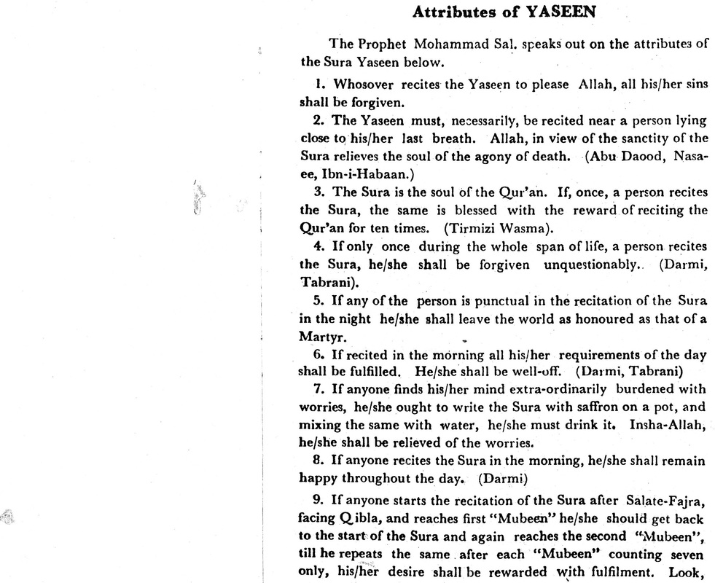

(PLEASE SCROLL DOWN FOR IMAGE)
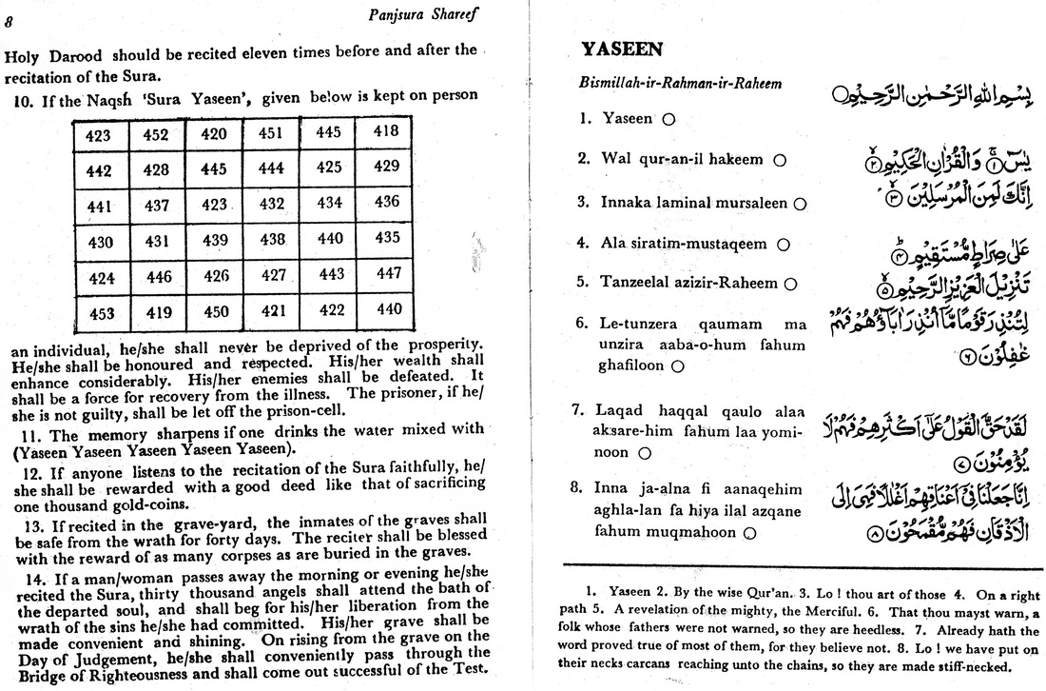

LEASE BRING THIS TO THE ATTENTION OF THE MUSLIM STUDENTS ASSOCIATIOM
UMAR AZAM <dr.u.azam@gmail.com> | 3/31/14
to info

VALUABLE ISLAMIC RESOURCES BY EMAIL
UMAR AZAM <dr.u.azam@gmail.com> | 3/23/14
to halalfoods, foodscientist1

SALAM,

MAY ALLAH BLESS ALL OF YOU FOR YOUR EXCELLENT WORK! AMIN!

PLEASE SEE MY WEBSITE: http://halal-ingredients.weebly.com

ALSO,

SALAM,

PLEASE BRING THIS TO THE ATTENTION OF YOUR MEMBERS AND OF COURSE YOU YOURSELF ARE WELCOME TO MAKE THE REQUEST.

I CAN SEND BY EMAIL THE FOLLOWING VALUABLE RESOURCES TO THE STUDENT MAKING A REQUEST TO ME:
1. ENTIRE HOLY QURAN PDF – ARABIC
2. ENTIRE HOLY QURAN PDF – ENGLISH
3. SAHIH BUKHARI PDF
4. SAHIH MUSLIM PDF
5. DUA-E-AZAFA RIZQ
6. DIAGRAM OF THE FAMILY TREE OF THE PROPHET MUHAMMAD [S.A.W.]
7. E-BOOK OF ISLAMIC DUAS
8. ISLAMIC MARRIAGE GUIDE PDF
9. ISLAMIC E-CALENDAR FOR 1435 A.H.
10. POWER OF DUROOD
11. THE ENTIRE HOLY QURAN IN ANY MAJOR WORLD LANGUAGE – PLEASE STATE WHICH LANGUAGE REQUIRED
PLEASE BRING THIS EMAIL TO YOUR MEMBERS’ ATTENTION. I’M NOT VERY BUSY AT THE MOMENT AND CAN SEND THE RESOURCES WITHIN 24 HOURS TO ANYONE MAKING A REQUEST TO: dr.u.azam@gmail.com

DR UMAR
www.dr-umar-azam.com
S. Rasheed Ahmed <halalfoods@hotmail.com> | 3/24/14
to me

Assalam O Alaikum
Thanks for your e-mail and I went to your website. Mentioning of Quran e Shareef, Bukhari Shareef, Muslim Shareef and Power of Darood shareef are very good mashallah.
Wishing you best for work.
Syed Rasheeduddin Ahmed
www.muslimconsumergroup.com
www.canadianhalal.com

Question about featuring your site powerofdurood.weebly.com
ReadyGraph <nick@readygraph.com> | 3/26/14
to me

Hello,
I work at ReadyGraph, where I help grow the world's most interesting websites. I'm really impressed by your site:powerofdurood.weebly.com
I would like to partner with you to feature your site to new users. You can learn more here to see how it works. In exchange for considering this, you will get lifetime access to our user growth engine for your site.
Thank you and please let me know if you have any questions.
Best,
Nick, Founder
readygraph.com
Address: 20 Jay St. New York City
Email: nick@readygraph.com
Phone: 862.205.4769

if you would like to unsubscribe click here. 2013, ReadyGraph. 20 Jay St. New York City, NY, 11201

FREE ISLAMIC RESOURCES
ahmed sarraj <sarraj66@gmail.com> | 3/23/14
to me

Salam,

It was brought to my attention that you are currently offering to send some very valuable resources per request. If it is not too much of a burden, I would be more than happy to request the following:

1. ENTIRE HOLY QURAN PDF – ARABIC
2. ENTIRE HOLY QURAN PDF – ENGLISH
3. SAHIH BUKHARI PDF
4. SAHIH MUSLIM PDF
5. DUA-E-AZAFA RIZQ
6. DIAGRAM OF THE FAMILY TREE OF THE PROPHET MUHAMMAD [S.A.W.]
7. E-BOOK OF ISLAMIC DUAS
8. ISLAMIC MARRIAGE GUIDE PDF
9. ISLAMIC E-CALENDAR FOR 1435 A.H.
10. POWER OF DUROOD

Jazakallah Khayran in advance and may Allah accept your generosity inshaAllah.

Best,
Ahmed Sarraj

Harvard University says Quran verse is one of the greatest expressions of justice
R M <mriyaz.rm@gmail.com> | 3/23/14
to

Harvard University says Quran verse is one of the greatest expressions of justice
Thursday 24 January 2013 - 15:16

Omar Bihmidine

Omar Bihmidine is a junior high school teacher of English in Sidi Ifni city. He obtained his Associate Degree at Choaib Eddoukali University in 2008. He earned his B.A. from Ibn Zohr university, Agadir. His writings take the form of short stories, poems and ...

Rabat- The U.S. Harvard University, one of the most prestigious institutions in the world, has placed a Quran verse at the entrance of its faculty of law.
Described by the institution as one of the greatest expressions of justice in history, Verse 136 of Surah Al Nisa (The Women Chapter) is dedicated to humanity as the best expression defending and articulating justice.
“O you who have believed, be persistently standing firm in justice, witnesses for Allah, even if it be against yourselves or parents and relatives. Whether one is rich or poor, Allah is more worthy of both. So follow not [personal] inclination, lest you not be just. And if you distort [your testimony] or refuse [to give it], then indeed Allah is ever, with what you do, Acquainted.” Surat An Nisa 4: 135
According to the Saudi Arabic language daily Ajel, a Saudi Student at Harvard published the picture of the verse on his Twitter page.
“I noticed that the verse was posted by the faculty of law, which described it as one of the greatest expressions for justice in history,” Abdullah Jumma said.
Justice quotations were selected among 150 contributions from law school faculty, staff and students. Yet, the three unanimously appreciated and displayed at the faculty entrance are quotes taken from St. Augustine, the Holy Quran and the Magna Carta.
According to the official website of the university, The Words of Justice exhibition is a clear sign of humanity’s craving for fairness on this earth.
At present, visitors to Harvard, researchers in particular, have the chance to identify themselves with the best articulations of justice since time immemorial.
Harvard University, the oldest institution of higher learning in the United States, was founded in Cambridge, Massachusetts in 1636.
© Morocco World News. All Rights Reserved. This material may not be published, rewritten or redistributed
http://www.moroccoworldnews.com/2013/01/75199/harvard-university-says-quran-verse-is-one-of-the-greatest-expressions-of-justice/

(PLEASE SCROLL DOWN FOR IMAGE)

Your HalalGoogle - by Awliyā for spreading Islam answer has a new comment
HalalGoogle - by Awliyā for spreading Islam <no-reply@halalgoogle.com> | 3/21/14
to me

Your answer on HalalGoogle - by Awliyā for spreading Islam has a new comment by khan:
thank you very much
may ALLAH bless you
include me in your duas
thanks again :
Your answer was:
WA LAIKUM SALAM,
ASSUMING THAT THE MINISTER IS OF THE OPINION THAT YOU ARE ABLE TO DO JOB, IT IS OF COURSE HALAL. EVEN IF YOU WERE UNQUALIFIED FOR THE JOB ANDS IT WAS CORRUPTION ON THE PART OF THE MINISTER, IT WOULD STILL BE HALAL BECAUSE IF THE EMPLOYER TOOK YOU ON, THAT WQOULD BE THE HALAL PART AND NOT YOUR RESPONSIBILITY FOR THEIR DECISION. IF YOU THEN GOT FIRED FOR NOT DOING THE JOB PROPERLY, THAT WOULD BE JUST DESSERTS. BUT IF YOU COULD DO THE JOB WHILE NOT FORMALLYT QUALIFIED TO DO SO, IT WOULD STILL BE HALAL BECAUSE YOUR ABILITY TO DO THE JOB WOULD 'QUALIFY' YOU. SO, GO AHEAD WITH ANY RECOMMENDATIONS - THE WORLD IS NOT STRICTLY A MERITOCRACY ANYWAY.
DR UMAR
http://allah-azawajal.weebly.com
http://powerofdurood.weebly.com
You may respond by adding your own comment:
http://halalgoogle.com/88/getting-job-through-approach?show=90#a90
Thank you,
HalalGoogle - by Awliyā for spreading Islam

