ASKING ADVICE OF DR UMAR ELAHI AZAM
Vol. 1
Emails from the Archive of Dr Umar Azam
Manchester, UK
February 2015

Dream
Digital Empire | Feb 4 (4 days ago)
to me

A.salam
Please interpret this dream of mine which i just saw today.
I saw that there were 2 girls at my place both of them used to study with me ,one was in school and other at the university. I saw both were standing together looking at a shoe ( which i have at the shop) and one of them asked its price i said its right there at the bottom and then she said how can you people sell things so cheap ( as if we were a big brand) and i said actually the price that is on it is incorrect it 200 prk cheaper than that stated on it. Then they went in my home and i saw that my house was in bad condition there were also a few cracks on the floor and i said to my self lets hope so they didn't saw this ( the fact is that the house in real is in bad condition and needs repairs and maintenance but my family is going through some financial problems since the last one year). Then i saw there was something about the internet connection being 32mpbs and then i saw the hadith book TIRMIZI.
END DREAM
Jazak Allah khair.

UMAR AZAM <dr.u.azam@gmail.com> | Feb 4 (4 days ago)
to Digital

WA LAIKUM SALAM,

YOUR DREAM COULD BE TELLING YOU TO START A NEW VENTURE SELLING GOODS ON THE INTERNET [SHOE, INTERNET CONNECTION BEING 32MPBS] WHICH WILL SOLVE YOUR FINANCIAL PROBLEMS [DELAPIDATED HOUSE]. BUT KEEP RELIGIOUS TOO AS WELL AS BUSINESS-MINDED [TIRMIZI].

DR UMAR

Digital Empire | Feb 5 (3 days ago)
to me

Thanks , I will say one thing for sure this is the most correct interpretation of my dream, recently i had been working on my businesses E-store and its being developed and will start soon.....in sha Allah

Dream
Digital Empire | Feb 5 (3 days ago)
to me

A.salam
Please interpret this dream of mine.
Background: I am waiting for my exam results which are near. And my friends got a head of me in studies as i failed twice due to my bad health , which is due to magic which had been practiced upon me and since then i am unable to give proper time to my studies.
Dream: I was in masjid and i think i was reciting the quran in my heart when a friend of mine ( who is the son of the Imam of the masjid) came to me and offered me to come along with him to drink milk. So i went there were other people with us as well and we bought two big bottles of milk from a milk shop. One bottle had in it plain milk while the other one had in it chocolate flavored milk. I think i drank the milk which was plain. Then all of he asked me and others to pay for the milk and everybody contributed but i had no money so i took 100 pkr from my dad, who was in the masjid but the friends said you have to contribute 200 prk and i said i am not paying another 100 pkr. But later i decided to bring the remaining 100 prk from home and give it to the Imam's son. On my way i saw a few friends of mine who were my class mates and are now a head of me in studies they were 3 , one of them has completed his Acca and the other two made there qualifying attempt and the asked me why were you left behind so i replied i had been ill and therefore was not able to give proper time to my studies and then i moved on.
Then i was searching for there Imam's son and the were many rooms there and i was confused that where is he. So i opened a door and the room was a dark one and then i came out as some one from inside was saying something to me and his voice resembled to that of the imam but the voice sounded a little bit scary. Then i saw that there was another room and its door was opened and i saw my friend from outside, i saw he was using a computer and i told him about the voice i heard so he went with me to that room he looked inside and it was the imam's son in law there( his daughter isn't married yet).
End dream
Jazak Allah Khair.

Digital Empire |  | Feb 5 (3 days ago)
sorry I forgot to mention one thing and that is that when i was carrying the ... the remaing money i was paying 120 or 130 PKR instead of 100 PKR.

UMAR AZAM <dr.u.azam@gmail.com> | Feb 5 (3 days ago)
to Digital

WA LAIKUM SALAM

YOUR DREAM IS TELLING YOU THAT YOU ARE CORRECTLY GUIDED IN RELIGION [.MASJID, RECITING QURAN IN HEART, IMAM, MILK] AND THAT YOU HAVE HAD FINANCIAL PROBLEMS [COULDN'T PAY PKR 200] BUT YOU WILL GET MORE MONEY [PAID MORE THAN REMAINING PKR 100]. THE DARK ROOM SYMBOLISES THE TROUBLES YOU HAVE HAD IN LIFE [EG BAD HEALTH BECAUSE OF JADOO]. BUT YOUR SITUATION WIILL IMPROVE [COMPUTER IN ROOM, IMAM'S SON-IN-LAW]. SO KEEP YOUR SPIRITS HIGH.

DR UMAR

Digital Empire | Feb 6 (2 days ago)
to me

Does it says anything about my exam results.

Jazak Allah

UMAR AZAM <dr.u.azam@gmail.com> | Feb 6 (2 days ago)
to Digital

It doesnt but i hope u will inshAllah pass because there wasnt anything in the dream to suggest FAILING exams
Digital Empire | Feb 6 (2 days ago)
to me

Jazak Allah

Dream
Digital Empire | Feb 2 (6 days ago)
to me

Assalmulalikum wa rehmatullah
Please interpret m dreams:
1) I was in a masjid and the prayer over and i stood up to leave for home and when i stood up there was someone right next to me and he was sitting on the floor that person grabbed my hand, tightly i think.
2) i saw my maid had a fight with my neighbor's son in law and then i saw my uncle and another neighbor of mine were at house of the neighbor with whom the maid has a fight and both of them were also angry fighting the same neighbor and then i saw my uncle and the neighbor who was with my uncle fighting against the other one was having a fight with my uncle. I saw i was in the drawing room and the glass of three windows broke and from each window entered a new born baby 2 of them were boys and 1 was a girl.
I also saw that beside the door of the masjid there was a shelf and in it were placed some shoes ( i have business and we deal in shoes as well) and a women was asking me the price there were 2 pairs in the shelf , one of them i have seen at my shop and the other one i saw the first time. And a women asked me their price and i said its 450 pkr and other one's price was 1700 ,i think.
End dream

UMAR AZAM <dr.u.azam@gmail.com> | Feb 2 (6 days ago)
to Digital

WA LAIKUM SALAM,

YOUR FIRST DREAM IS TELLING YOU THAT YOU ARE NEEDED BY MASJID OR MASAAJID OR HELPING THESE HOUSES OF ALLAH IN SOME WAY

THE SECOND DREAM IS TELLING YOU THAT YOU MIGHT BE UNHAPPY IN YOUR PRESENT AREA AND WISH TO MOVE SOMEWHERE NEW

THE THIRD DREAM IS TELLING YOU THAT NEW THINGS WILL START TO HAPPEN IN YOUR LIFE AND YOUR LIFE WILL GIVE COMFORT TO OTHERS, OR BE COMFORTABLE TO YOU, IN TWO WAYS , ONE WAY BEING BETTER THAN THE OTHER.

DR UMAR

Neighbor
To dream of having a good neighbor signifies enjoyment and tranquility at home. If you dream of an angry or unfriendly neighbor, then it signifies dissension and disappointment. There is a waking issue that you need to address with your neighbor. Alternatively, the dream could mean relocation from your home. Perhaps you are in need of a change of scenery.http://dreammoods.com/cgibin/dreamdictionarysearch.pl?method=exact&header=dreamsymbol&search=neighbour
Muhammad Latif Chaudhery <latif.m.chaudhery@gmail.com> | 11/3/13
to me

Thank you sir. Jazak Allah.
By the way are you aware of some book which describe the liturgy of Salat before the advent of Islam,

On 03/11/2013 17:56, UMAR AZAM wrote:
SALAM

UMAR AZAM <dr.u.azam@gmail.com> | 11/3/13
to Muhammad

SALAM, BR LATIF

I HAVE DONE A SEARCH OF YOUR WORDS

liturgy of salat before advent of islam

ON GOOGLE AND FOUND
About 2,720,000 results (0.36 seconds)
PLEASE DO THE SAME AND SEE IF WHAT YOU REQUESTED IS THERE BECAUSE IT'S ALL QUITE CHALLENGING FOR ME.
DR UMAR

Holy Quran
UMAR AZAM <dr.u.azam@gmail.com> | Jan 20
to ramshasultan95

Salam, Ramsha
I emailed u the Electronic Holy Quran yesterday. If ud like the PRINTED Quran, email ur full postal address,along with a contact tel. no. Dr Umar

Ramsha Sultan | Jan 20
to me

Walekumassalam Dr. Umar
Yes i would like to have a Printed Copy Of The Quran.

My Name: Ramsha Sultan

JazakAllah . May Allah Reward You With Jannah.

UMAR AZAM <dr.u.azam@gmail.com> | Jan 20
to mohamedshrok20., burhankilic23, Ramsha

Salam, Brs Salah and Burhan, please send the Holy Quran and Islamic books To Ramsha, please see forwarded mail. Jazak Allah. Dr Umar

Ramsha Sultan | Jan 28 (11 days ago)
to me

Assalamualaikum
I have received a big bundle of Islamic Books alongwith a Quran.
You people have surprised me by sending soo many books,
May Allah reward you all with Jannah for carrying out such an excellent work.
I am a student and this help of yours has facilitated me a lot.
I own a page on fb and I have shared your website on it.
https://www.facebook.com/AllahAndProphetMuhammad.PBUH?ref=hl
Do like and spread this page.

JazakAllah Khair.
Attachments area
Preview attachment 20150128_154017.jpg

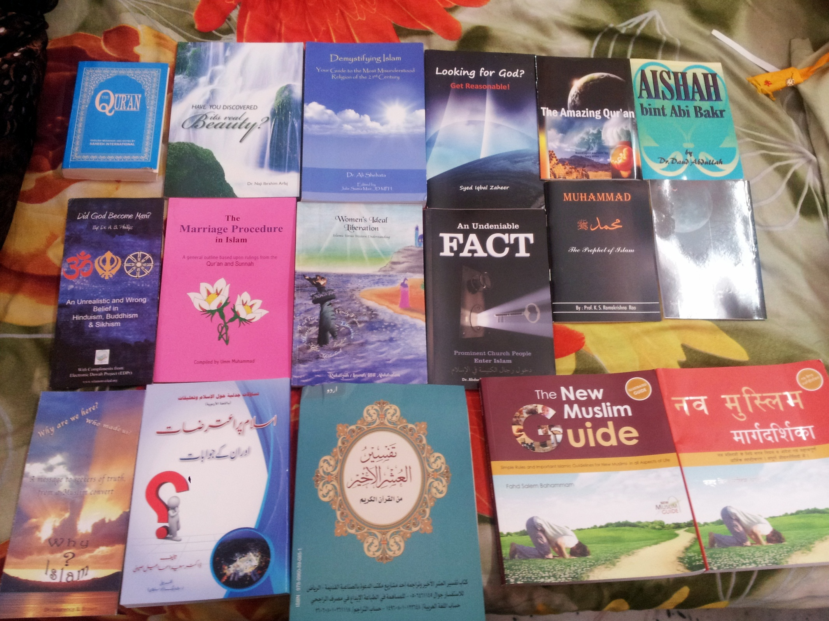
20150128_154017.jpg

UMAR AZAM <dr.u.azam@gmail.com> | Jan 28 (11 days ago)
to Ramsha

WA LAIKUM SALAM,

YOU'RE MOST WELCOME, RAMSHA. SO YOU GET SAWAB, PLEASE ASK YOUR FELLOW STUDENTS TO EMAIL ME TO GET THE RESOURCES.

DR UMAR

UMAR AZAM <dr.u.azam@gmail.com> | Jan 28 (11 days ago)
to mohamedshrok20.

JAZAKALLAH, KHAIR, BR SALAH

PLEASE SEE FORWARDED MAIL. BEING A STUDENT, MISS RAMSHA IS VERY GRATEFUL FOR ALL THE FREE LITERATURE THAT YOU HAVE SENT HER.

DR UMAR

Re: aa..@786/92.. kindly tell me how much the cost part1 of english translation of urdu translation by Alaa Hazrat Imam Ahmed Raza Khan translation of the arabic quran as no reply from uk ahle sunnat
WARISHAULLY FAROOK | Jan 28 (11 days ago)
to info, bcc: me

aa.. kindly advise if you got this quran edition pl.
jzklh
farook@02082523855

On 27 January 2015 at 22:47, Umar Azam <786dr.azam@gmail.com> wrote:
SALAM, BR FAROOK

PLEASE CONTACT AN ISLAMIC BOOKSHOP ABOUT THIS MATTER, A SHOP WHOSE STAFF ARE VERY KNOWLEDGABLE ABOUT SUCH ENQUIRIES:

ROLEX BOOKS,

TEL. 0161 225 4448

DR UMAR

On Tue, Jan 27, 2015 at 6:56 PM, <farook1786@ntlworld.com> wrote:
very urgent pl. also transliteration thereon imam raza translation most welcome.
sukraan/jzklh

farook@119 gordon rd, ilford, essex, g1 2xt, uk. tel:0208 2523855

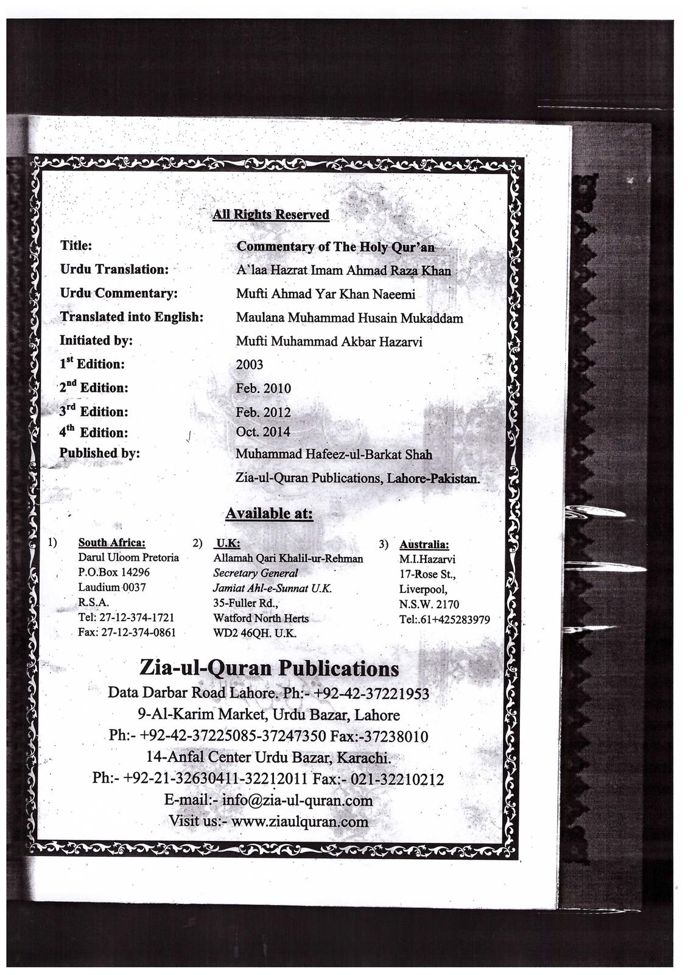

aa..@786/92.. kindly tell me how much the cost part1 of english translation of urdu translation by Alaa Hazrat Imam Ahmed Raza Khan translation of the arabic quran as no reply from uk ahle sunnat

New Form Entry: Power of Durood Site Form
Mayallahforgiveusall@gmail.com <no-reply@weebly.com> | Jan 27 (12 days ago)
to me

You've just received a new submission to your Power of Durood Site Form.

Submitted Information:
Name
Laila [Name has been changed]
Email
Comment
Please ya Muslimeen... I'm your sister in Islam and i'm desperate need of duas. My life is turned upside down and i'm praying non-stop,In Sha Allah I will get my health back. Please make duas for me. My life is very bad at the moment and I need my Muslim brothers and sisters to make duas. I'M DESPERATE, PLEASE HELP. Thanks and may Allah reward you.

Salam
UMAR AZAM <dr.u.azam@gmail.com> | Jan 27 (12 days ago)
to Mayallahforgiv.

Regret To hear of ur problems, Laila. What exactly is wrong? Dr Umar

Laila | Jan 27 (12 days ago)
to me

Wa'alykum salaam,

Thanks for caring. I did some horrible thing and didn't follow my Deen and now I'm in a situation where I'm not sure what to do. I turned to Allah and I pray non-stop and make duas. But, I'm sure if my duas will be accepted and I'm very concerned about my health and my future. I'm in very desperate situation, which I wish I wasn't in but I'm. I always been a good girl but I met a bad man and now my life might be over. I can't talk to my family about it because they see me as a "perfect" can't do wrong person but my life is down the drain and I cant stop crying inside. Please make dua's for me. I really need it desperately.

UMAR AZAM <dr.u.azam@gmail.com> | Jan 27 (12 days ago)
to Laila

Well The first thing u need to acknowledge is that human beings CAN make mistakes, and Allah's Mercy is Greater than Allah's Anger, it could be that the phase that u are going through is expiation itself for ur sin & then u wont be punished for it again in this world or the next! Dr Umar

Laila | Jan 27 (12 days ago)
to me

That puts my mind at ease, Jazaka Allah khar brother. May Allah reward you for your comforting words...

RE: FREE AAB-E-KAUSAR BOOK OF BLESSINGS ON THE PROPHET S.A.W.
SIKANDER HAYAT | Jan 24
to me

Dear Dr for my knowledge could you guide me where the words of Darood are given.Couldnt find in Quraan
UMAR AZAM <dr.u.azam@gmail.com> | Jan 24
to SIKANDER

Yes, please see The first page of my Site http://powerofdurood.weebly.com and then please Sign the Guestbook. Dr Umar

Dream interpretation
DR NADIA [NAME HAS BEEN CHANGED] | Jan 22
to me

Aslam Allaikum
I saw deeam at around 9:am
My husband is asking my little brother to give him warm water for gargels, my little brother is giving him warm water in glass my husband is in hurry and he wrongly drunk it istead of doing gargels he starts crying dye to pain wondering here and there I am praying for him get relieve trying to give her cold water but my mother is asking not to give him cold 1 as cold water usually causes boils to be formed my other brothers are giving him paste and other ointments with their application my husband gets relive from pain and he becomes alright .
I am seeing his tongue has no boils .
Kindly interpret my dream brother
JazakuAllah khairun kaseera
Sent from Samsung Mobile

UMAR AZAM <dr.u.azam@gmail.com> | Jan 22
to dr Nadia

WA LAIKUM SALAM, DR NADIA

YOUR HUSBAND HAS BEEN SUFFERING FAMILY PROBLEMS AND SUFFERING EMOTIONALLY BUT THESE PROBLEMS WILL GO AWAY SOON.

Water
To see water in your dream symbolizes your subconscious and your emotional state of mind. Water is the living essence of the psyche and the flow of life energy. It is also symbolic of spirituality, knowledge, healing and refreshment. To dream that water is boiling suggests that you are expressing some emotional turmoil. Feelings from your subconscious are surfacing and ready to be acknowledged.�You need to let out some steam.�To see calm, clear water in your dream means that you are in tune with your spirituality. It denotes serenity, peace of mind, and rejuvenation. If someone throws water at you in your dream, then it implies that you need to show more of your emotions. You have been too disconnected from others. Alternatively, it may mean that you need to cool off.
http://dreammoods.com/cgibin/dreamdictionarysearch.pl?method=exact&header=dreamsymbol&search=water

DR NADIA | Jan 23
to me

JazakuAllah brother

Sent from Samsung Mobile

RE: YOUR QUESTIONS
UMAR AZAM <dr.u.azam@gmail.com> | Jan 22
to jafreyomi

WA LAIKUM SALAM, BR OWAIS

THE PROPHETS.A.W. WAS IN MEDINA FROM THE YEARS 622 TO 630, SO THEY SPENT 8 YEARS THERE

(5) Verily, those who LOWer their VOICEs in the presence of Allah's Messenger (صلى الله عليه وسلم), they are the ones whose hearts Allah has tested for piety. For them is forgiveness and a great reward.
( سورة الحجرات , Al-Hujraat, Chapter #49, Verse #3)
(Arabic, Transliteration, Urdu (Ahmed Ali) , Urdu (Jalandhry) , Yusuf Ali, Shakir, Picthal, Mohsin Khan, French, Spanish, Indonesian,Malay, German, Bosnian, Russian, Tafsir - Jalal ad-Din, Tafsir - King Fahad Quran Complex)

PLEASE USE:

http://www.searchtruth.com/

THE HOLY QURAN SEARCH ENGINE

Owais Jafrey | Jan 23
to me

No words to thank you enough my dear brother Umar. I know who to bank upon for such needs of knowledge. You are truly Allah's blessing for me. Zindahbaad and Wasslaam.

Gratefully ever yours,
Owais

AKHBAR-E-JAHAN <theeditor.aj@gmail.com> | 12/17/14
to me

Sir do you have Molana Modoodi translation
Regards
Azfar

UMAR AZAM <dr.u.azam@gmail.com> | 12/17/14
to AKHBAR-E-JAHAN

BR AZFAR,

IT'S IMPRACTICAL TO SEND YOU 119 PDF FILES BY EMAIL OF MAULANA MADOODI'S TAHFEEM UL QURAN TRANSLATION & COMMENTARY IN URDU. SO PLEASE DOWNLOAD THE FILES FROM:

http://www.2lets.com/2012/09/tafheem-ul-quran-in-urdu-pdf-free.html

MAY ALLAH BLESS YOU.

DR UMAR

Free Islamic Apps (Android)
Ziya <ziya.live@gmail.com> | Jan 22
to bcc: me

Category: Free Islamic software
Platform: Android Mobile App
Name: Quran For All

Description: “Quran For All” is a one of the best Android App available today. It is easy to navigate and use, even a child can access the beautiful treasure of Quran to learn and seek the divine guidance. Launched initially with with Marathi, English, Hindi, Urdu, Tamil, Malayalam and Sindhi translations and work on translation in all major Indian Languages like Bangla, Kannad, Telugu, Gujrati, Punjabi etc. is going on.

Sharing is very easy and the search facility is also available. Translation is given beneath of each verse (ayah) in Arabic, which makes learning very easy.

Features:

Developer: Jamaat-e-Islami Hind, Maharashtra
Website: jihmaharashtra.org
Language: Marathi (Available) and English, Hindi & Urdu (being added)

Background: Wonderful color combination with artistic background.
– Unicode
– Multi-language Index
– Verse (Ayah) Bookmarking
– Multi option App Sharing

Download link: Click here to download or paste this link in your browser
https://play.google.com/store/apps/details?id=com.quranforall

Category: Free Islamic software
Platform: Android Mobile App
Name: Islam For All
Description: “Islam For All” is an encyclopedic Android App available on Google play. It contains a very rich collection of Islamic books. This app intends to provide teachings and commandments of Islam to augment the knowledge, so that a Muslim can profess his faith and practice the religion in a way as desired. This app also offers basic understanding of Islam to the non-Muslims in an easy manner. Besides this, this app also contains the materials of Islam introduction (Dawah) campaign of Jammat-e-Islami Hind, Maharashtra, scheduled to start on 9th January, 2015.

Features:

Developer: Jamaat-e-Islami Hind, Maharashtra

Website: jihmaharashtra.org

Language: Marathi (Available) and English, Hindi & Urdu (being added)

Background: Wonderful color combination with artistic background.

– Unicode
– Multi-language Index

Download link: Download link: Click here to download or paste this link in your browser
https://play.google.com/store/apps/details?id=com.islamforall_

Mobile App:

Category: Free Islamic software

Platform: Android Mobile App

Name: Muhammad For All

Description: “Prophet Muhammad (PBUH) for All” is an Android mobile app developed with a view to provide the holy life and teachings of prophet Muhammad (PBUH). This app contains an introduction to his life and prophecy regarding him in the scriptures of other religions. This is a very good source of information regarding the last prophet of Allah (SWT) available at the finger tip.

Features:

Developer: Jamaat-e-Islami Hind, Maharashtra

Website: jihmaharashtra.org

Language: Marathi (Available) and English, Hindi & Urdu (being added)

Background: Wonderful color combination with artistic background.
– Unicode
– Multi-language

Download link: Click here to download or paste this link in your browser
https://play.google.com/store/apps/details?id=com.muhammadforall

ISLAMIC BOOKS IN ENGLISH
UMAR AZAM <dr.u.azam@gmail.com> | Jan 19
to aalazami

SALAM, BR MAMOON

GOOD NEWS FOR YOU! YOU CAN DOWNLOAD 48 COMPLETE BOOKS ON ISLAMIC TOPICS IN ENGLISH FROM THE FOLLOWING WEBSITE:

http://www.islamfactory.com/books/

DR UMAR

Dream
SS | Jan 11
to me

Salaam, tonight i had a dream that i m sleeping with quilt over my
head & i feel someone came,slept besides me &my throat get choked i
recite manzil with difficulty,on reciting aayatal kursi i get some
relief,on recitin qulillamu maalikal mulk...my voice gets louder & i
find a handsome boy(jinn) unconscious, after sometimes he comes to me
& i ask him to read 5 time salah

UMAR AZAM <dr.u.azam@gmail.com> | Jan 11
to SS

WA LAIKUM SALAM, SHEIKH

IF YOUR DREAM IS TRUE [AND NOT ALL DREAMS ARE], IT COULD MEAN THAT, IN THE FUTURE, YOU MAY HAVE A CLOSE ENCOUNTER WITH A PERSON WHO IS AFFECTED SUPERNATURALLY [HANDSOME JINN IN BED].

Jinn — (Sing. Jinni) A creation from a smokeless fire. Among the Jinn, some are believers while others are satans. This is in contrast to human beings who are created from earth and among them some are believers and others are human satans. Jinn in a dream represent fraud, deceit, cunning, perfidy, treachery, theft, alcoholism, invented religious practices, travels, music, bars, tricks, sleight of hand, illusion, sorcery and magic. If one is transformed into a Jinni in a dream, it means that he will acquire such qualities. If one meets a Jinni who displays truthfulness, knowledge and wisdom which is recognizable by the person in the dream it means that he will receive good news. Seeing Jinn standing by one's door in a dream means losses, a vow that must be fulfilled, or experiencing bad luck. Seeing Jinn entering one's house and doing work there in a dream means that thieves may enter that house and cause major losses. If one sees himself teaching the Quran to a gathering of Jinn in a dream, it means that he will be appointed to a leadership position. Accompanying Jinn in a dream means familiarity with, and keeping the company of men of knowledge, or people of inner knowledge. If one marries a female from amongst the Jinn in a dream, it means that he will marry an insolent wife, or that he may suffer a great calamity. If a righteous person sees himself chaining Jinn in a dream, it means that he holds fast to his prayers, fasting, controls his carnal self and base desires. Engaging in a battle with Jinn in a dream means that one will be safe from their evil. To befriend a known leader from amongst the Jinn in a dream means becoming a police officer and make it one's profession to pursue criminals and bandits. It also could mean that one might become a guided man of knowledge or a teacher. Seeing Jinn gathering in a known locality in a dream also may indicate the presence of snakes, scorpions, or what human beings may fear in the wilderness. (Also see Dragon; Pumpkin) Source:Strong

DR UMAR

SS | Jan 12
to me

Can u plz explain in detail

UMAR AZAM <dr.u.azam@gmail.com> | Jan 12
to Sheikh

Well i cant because no one knows the future, could be a wife afflicted a little by jinn but u could heal her (reading namaz 5 times a day), only u know ur own circumstances, now and in the future, and such a dream may be false anyway, so dont worry!

SS | Jan 12
to me

But i am bachelor

UMAR AZAM <dr.u.azam@gmail.com> | Jan 12
to Sheikh

Dream could refer to ur future wife, i didnt say u are married

My istukhra dreams about laparoscopy training at india
DR NADIA [NAME HAS BEEN CHANGED] | Jan 10
to me

Aslam Allaikum
Dr sb JazakuAllah khair for guiding me every time
As I am a doctor gynaecologist, I am interested in laparoscopy (advanced techniques of doing surgery), for that I wish to go to India to get training, I did istukhra for that purpose :kindly interpretate my dreams
1st day dream -1st dream I am at some place where there is white snow every where I am feeling little suffocation due to heavy snow,2nd dream -my senior gynaecologist came to my clinic and I an requesting her to teach some surgeries as my mother in law is ill now I cant learn from her (my mother in law in actuall is a doctor and suffered from stroke few years back)that senior doctor is litlle rude to me she is asking from my sister in law who is also gynaecologist in real life about my clinic that who is looking after the patients after surgery and are the patients remains stable after surgery , my sister in law replying her that I dont know much because I am not present at clinic all the time.after this that senior doctor asking me that you arrange the patients I will teach you surgery but I will come after few days at early morning 4:00am .I am little confused that how I will be able to arrange the patients in this short period, than some 1 is informing me that senior doctor is arrived for doing surgery I am confused how to arrang patient , at last I saw swelling on that seniir doctors feet and legs
2nd day dream-1st dream I saw that my freind shama is inviting me to dance on music in front of many females after little hesitation I agreed (in real life my freind is a doctor and want to accompany me for my trip to india)2nd dream -I saw tea pink colour and gray colour socks.3rd dream my auntee is laughing and asking me and my sister that you can change the position of the bed in this room
3rd day -I got order as junior specialist in some hospital but some 1 is saying their is no summer holidays in 1st year of job

Regards,
Dr NADIA

Sent from Samsung Mobile

UMAR AZAM <dr.u.azam@gmail.com> | Jan 10
to drshaziameer

WA LAIKUM SALAM, DR NADIA

SNOW REPRESENTS DIFFICULTIES AND HARDSHIPS. IN ALL OF THE ISTIKHARA DREAMS YOU PRESENT, THERE IS EITHER SOMETHING NEGATIVE [E.G. NO HOLIDAYS] OR SOMETHING UNNATURAL [E.G. PINK TEA].

IT CAN THEREFORE BE INFERRED THAT, WHATEVER YOUR PKANS ARE, THEY COULD BACKFIRE and lead to unhappiness.

DR UMAR
DR NADIA | Jan 10
to me

JazakuAllah brother

Sent from Samsung Mobile

